December 2022
Merry Christmas and Happy New year!
But the angel said to them, “Do not be afraid.^{w} I bring you good news that will cause great joy for all the people. Luke 2:10 (ESV) | 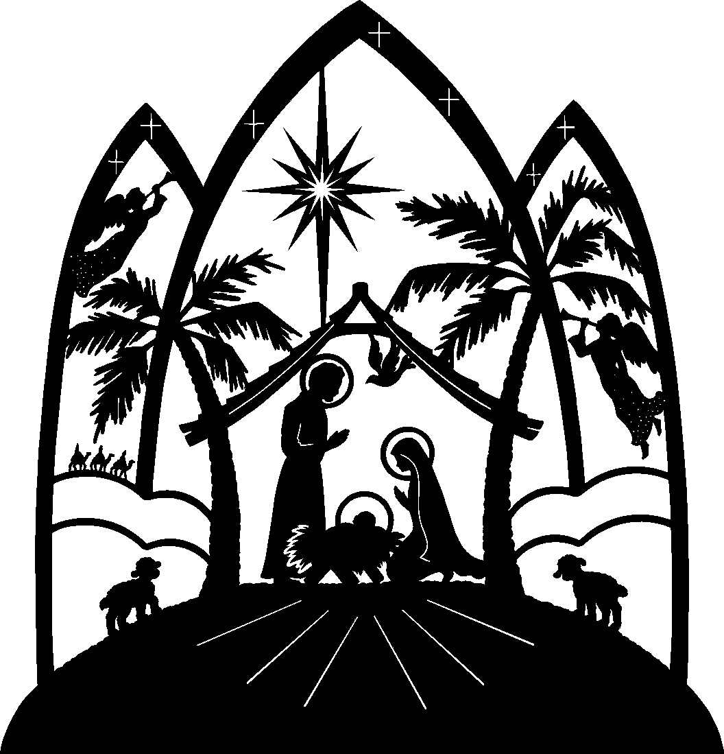
Sunday | Monday | Tuesday | Wednesday | Thursday | Friday | Saturday
27 | 28 | 29 | 30 | 1 | 2 | 3
1st Sun. of advent  Divine Ser. 10:30 am  Bible Study 9:30 am  Sun. School 9:30 am  Acolyte: Victor P. |  |  | Advent service  @ 7:00 pm |  |  | Ladies of Grace Luncheon @11:00
4 | 5 | 6 | 7 | 8 | 9 | 10
2nd Sun. of advent  Divine Ser. 10:30 am  Bible Study 9:30 am  Sun. School 9:30 am  Acolyte: Victor P. |  |  | Advent service  @ 7:00 pm
11 | 12 | 13 | 14 | 15 | 16 | 17
3rd Sun. of advent  Divine Ser. 10:30 am  Bible Study 9:30 am  Sun. School 9:30 am  Acolyte:Christine F. |  | 10 am Toronto circuit meeting | Advent service  @ 7:00 pm
18 | 19 | 20 | 21 | 22 | 23 | 24
4th Sun. of advent  Divine Service  10:30 am  Bible Study 9:30 am  Sun. School 9:30 am  Acolyte:Christine F. |  |  | St. Thomas, Apostle, |  |  | Christmas Eve, Candlelight Service (C) @ 7:00 pm
25 | 26 | 27 | 28 | 29 | 30 | 31
Christmas Day  Divine Service.  10:30 am  Acolyte:Christine F. | St. Stephen, Martyr | St. John, Evangelist | Holy Innocents, Martyrs

